Cheshire East Safeguarding Children’s Partnership
TRAINING UPDATE May 2024
Booking for JULY COURSES NOW OPEN!
We’re offering a HUGE variety of inspiring and accessible learning opportunities,
helping you to boost your practice confidence, knowledge and skills.
*SPACES AVAILABLE* on IN PERSON courses!
To justify running FREE face-to-face events, we need people to book and ATTEND please.
COURSES: Register using Teams links to access WEBINARS and to book IN PERSON course places
MAY | Tues  21st |  | Trio of Vulnerabilities |  |  | WEBINAR |  | Register here to ACCESS Trio of Vulnerabilities *WEBINAR*
 | Thurs 23rd |  | Fundamental Safeguarding |  |  | WEBINAR |  | Register here to ACCESS Fundamental Safeguarding *WEBINAR*
JUNE | Thurs  6th |  | Child Protection: Education as a Protective Factor SPACES - BOOK NOW! |  |  | IN PERSON  Oakenclough Family Hub |  | Register to ATTEND CP Processes *IN PERSON* at Oakenclough Family Hub
 | Tues 11th |  | LADO – Managing Allegations  SPACES – BOOK NOW! |  |  | IN PERSON  Macclesfield Town Hall |  | Register to ATTEND LADO *IN PERSON* at Macclesfield Town Hall
 | Thurs 27th |  | Safeguarding Children with Disabilities SPACES - BOOK NOW! |  |  | WEBINAR |  | Register here to ACCESS Safeguarding CWD *WEBINAR*
* JUNE SPECIAL GUEST EVENTS *
June 13th | Online Safety Live: explore latest guidance on digital safeguarding for children.  Please also see attached flyer |  |  |  |  | IN PERSON  Oakenclough Family Hub |  | Online Safety Live - FREE Tickets, 09:30-11:30 | Eventbrite  Online Safety Live - FREE Tickets, 13:30-15:30 | Eventbrite
June 26th | Centre of Excellence on Child Sexual Abuse Event *BOOKING NOW OPEN* |  |  |  |  | IN PERSON  Sandbach Town Hall |  | Register here to ATTEND CSA Event at Sandbach Town Hall
JULY | Tues  2nd | ACES and Trauma Informed Practices  *BOOKING NOW OPEN* | WEBINAR | Register here to ACCESS ACES and trauma Informed Practices *WEBINAR*
 | Thurs  4th | GCP2: using the NSPCC tool for neglect  *BOOKING NOW OPEN* | IN PERSON  Oakenclough Family Hub | Register here to ATTEND GCP2 course *IN PERSON* at Oakenclough Family Hub
 | Tues  9th | Harmful Sexual Behaviours: ERASE Tool *BOOKING NOW OPEN* | IN PERSON  Oakenclough Family Hub | Register here to ATTEND HSB *IN PERSON* at Oakenclough Family Hub
 | Wed  10th | Working Together 2024 Summary  *BOOKING NOW OPEN* | WEBINAR | Register here to ACCESS Working Together *WEBINAR*
ON-LINE SHORT sessions at mid-day:
Delivered via automatic invite for your convenience: *NO BOOKING REQUIREMENT*
You will find further information on each topic embedded in your invite.
MAY | Thurs 30th |  |  | LCSPR updates: essential partnership learning for everyone
JUNE | Weds 5th |  |  | How to… Work with Elective Home Education with the Attendance and Children Out of School Team
 | Weds 12th |  |  | Spotlight on… Your Youth Justice Service
 | Tues 18th |  |  | How to… Recognise Intelligence with the Police Intelligence Service
 | Weds 19th |  |  | Spotlight on… The Inclusion Quality Team
 | Thurs 20th |  |  | LCSPR updates: essential partnership learning for everyone
*REQUEST AN INVITE* – FREE opportunities to join training hosted by our partner organisations
May 23rd |  | 12-1pm |  |  | Resources, Tools & Programmes to Reduce Parental Conflict [hosted by CE Social Care] |  | ON-LINE |  | REQUEST AN INVITE  cescptraining@cheshireeast.gov.uk
June 4th |  | 9:30-11:30pm |  |  | Change, Grow, Live (CGL):  Parental Substance Misuse [hosted by CGL] |  | ON-LINE |  | REQUEST AN INVITE  cescptraining@cheshireeast.gov.uk
July 4th |  | 9:30-1pm |  |  | Pan-Cheshire Event: Responding to Sexual Assault & Violence [hosted by SARC & RASASC] |  | ON-LINE |  | REQUEST AN INVITE  cescptraining@cheshireeast.gov.uk
E-LEARNING:
- CESCP convenient learning through online modules is available via the Cheshire East Council Learning Lounge facility with *NEW COURSES* being added to broaden the choice available to all. To access and explore these, please follow this link for instructions to quickly make an account:
E-Learning (cescp.org.uk) or, simply log-in if you have a Cheshire East email address.

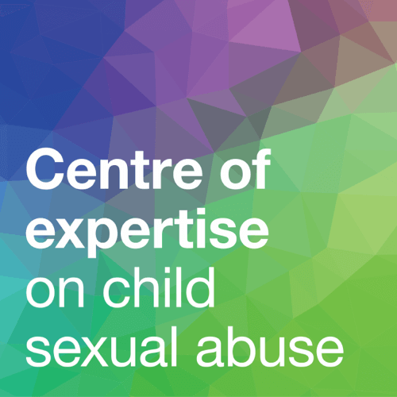
- Centre of Expertise on Child Sexual Abuse: This national organisation provides a range of FREE webinar e-learning opportunities as well as linked resources and tools: eLearning | CSA Centre

The Centre of Expertise is coming to Cheshire East on 26th June - Book your place now!
Other FREE & low cost Learning Resources:
- The Police and NHS have issued a SAFER SLEEP NOTIFICATION. Join their ‘Lunch & Learn’ session on Thursday 20th June, 12-1:30pm to find out more about this important initiative. See FLYER ATTACHED or Click here to join the SAFER SLEEP initiative session.

- ^{my}CWa has released their autumn TRAINING DATES: courses available via EVENTBRITE. We will advertise upcoming ^{my}CWa course dates through future CESCP newsletters; please explore Eventbrite to source events in the meantime.

- SWGfl from the UK Safer Internet Centre, is an excellent resource for exploring, understanding, reporting and mitigating the dangers of internet use. The charity is coming to Cheshire East in June (as above) FREE of charge. SWGfl are also currently offering low-cost training on ‘Sexploitation’. Please find more details or book a place with the FLYER attached.

- NEW! Two 7-minute briefings on ‘Professional Curiosity’ and ‘Working Together 2023’ are now available to share. Please find copies attached and distribute among teams.
And finally….
If you would like to see any multi-agency practice topic to support shared learning opportunities adding to our training programme, or you know of a great resource or service that you’d like to widely share, please contact us at: cescptraining@cheshireeast.gov.uk

HOME: Cheshire East Safeguarding Children's Partnership (CESCP)

Training: Courses available and links to book (cescp.org.uk)

